Claim the pending ADV_CAP_BATCH row (mark claimed by this hub); on success the Execution Unit later removes it, on error sets Error state- from tables message / MessageHeader
QISMessageId | LogType | State
MSG0000000777 (illustrative) | ADV_CAP_BATCH | BulkMessageAvailable

QISMessageId | LogType | State
MSG0000000777 | ADV_CAP_BATCH | Claimed → (removed on success)

Batch Process Enrollment is called
Sample payload that is loaded: programid=OHMCD-PCP-2026, capdate=2026-01-01, messagequeueid=MQ0000000045, firstmessageid=1, lastmessageid=50, batchcount=50, paymentid=PAY0000000100, affiliateid=PRV0001.

- Load programcap table details
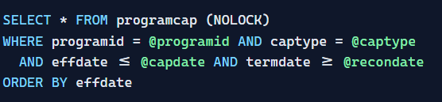

As the usetruecap='Y', capdate becomes 2026-01-31
- BatchEnrollProcess() loads every capmessagequeue row for this queue between firstmessageid and lastmessageid. Each row holds one enrollee's XML.
Query class: SELECT_capmessagequeue_BY_messagequeueid_firstmessageid_lastmessageid.cs (QUERYID 10603)
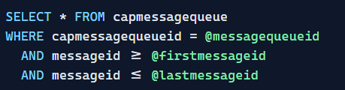
Output:
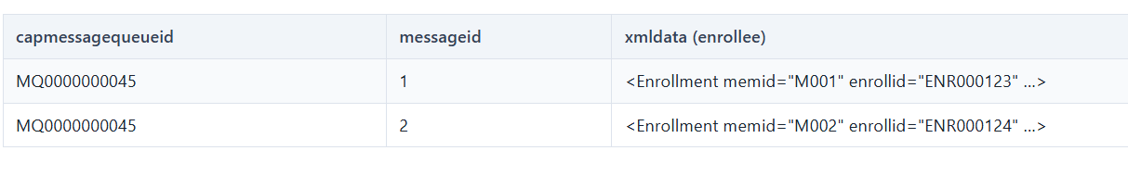
- LoadCapAdjustments() — read pending recon adjustments
Loads any PENDING RECON cap adjustments for this provider/program/members, so retro reconciliation can be applied to the cap calc.
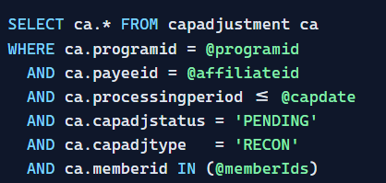
- Calculate Capitation
For each enrollee row the message is passed through five sub-objects in sequence. The first four read reference data; the last inserts the voucher lines.
CalculateCapitation: BuildCapAffils → BuildCapAmount → FundAllocation → FundAdjustment → StoreCapVoucher.

4 a. cBuildCapAffils — who gets paid & for which months
Capitation pays a provider for a member, so step one is resolving the member→PCP/network affiliation effective on the cap date, and building the list of months (from capdate back to recondate) that need settling.

Several gates are applied here: a suspended org policy month is skipped (no cap when the plan isn't active); pro-rata days are computed when enrollment starts/ends mid-month (pay only for covered days); carve-outs exclude benefits that another entity bears (no double-pay); and a month with an open payment already is skipped (no duplicate cap). PCP vs Global is chosen by the run type — here PCP, so payment resolves to the individual provider.

Member PCP affiliation and network are capdate are retrieved from below tables

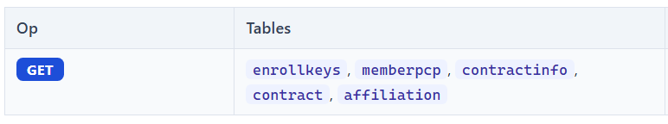

4b. cBuildCapAmount — the base PMPM amount
Now that we know who and which months, we compute the dollar amount. Depending on methodology this is either term-based (UseCapTermAmount) or factor-based (UseFlatFeeAmount, used by CAPFactors programs like this one).

The premium invoice data establishes the member's rate basis, and the cap factors (factorusage='CAP') provide the PMPM rate components — multipliers by age/geography/benefit tier that turn a base rate into the correct per-member monthly dollar figure.

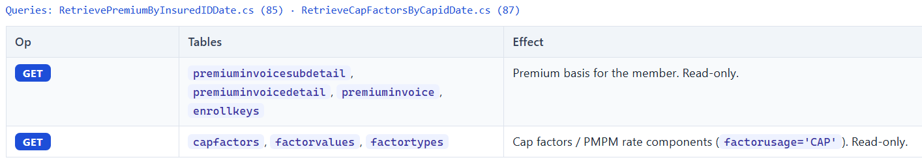

4c. cCapFundAllocation — split the amount across funds · 4d · cCapFundAdjustment — risk/month adjust

One PMPM dollar amount is rarely paid as one line. Allocation divides it across the configured funds (weekly vs withhold); adjustment then tunes each fund for member risk/conditions and for split-month or front-back-wash accounting if the capmethod requires it. Both run per member so each person's split reflects their own profile.

The weekly funds carry the money the provider gets on schedule; the withhold funds hold back a portion as an at-risk pool released later via reconciliation/performance. Risk adjustment raises the cap for clinically complex members and lowers it for healthy ones, so payment tracks expected cost rather than volume. usetruecap and usesplitmonth finalize the day counts and the exact end amount for partial-month situations. All of this is in-memory — nothing is written until 7e, so a mid-pipeline failure writes no partial ledger rows.


Allocates the calculated cap across funds (3 weekly + up to 3 withhold) and applies any recon adjustment. In-memory only — no rows written here.

4e cStoreCapVoucher — reconcile & persist the lines
This is the only stage that writes to the ledger, and it does so only after deciding, per month/fund, whether this is a brand-new MONTHLY voucher or a RECON correction. It must run last because reconciliation needs the fully computed, fund-split, adjusted amount to compare against what was already paid.

For the primary month it simply books a MONTHLY voucher. For a prior (recon) month it loads the prior voucher history and compares: if the new amount matches what was paid, it books nothing (and nets out the matching rows) — avoiding meaningless churn; if it differs, it books a RECON voucher for only the delta; if no prior voucher exists, it books a RECON for the full amount. This is how capitation self-corrects month over month while keeping MONTHLY (prospective) and RECON (retrospective) money cleanly separated for audit. One row is inserted per member × fund, all pointing at the shell paymentid.
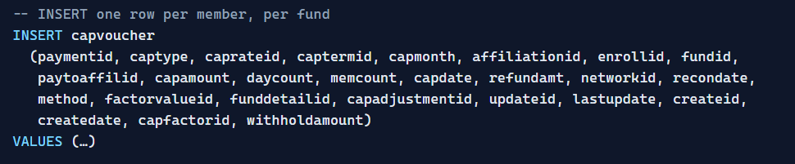

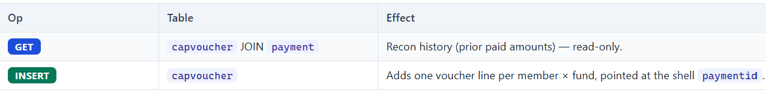
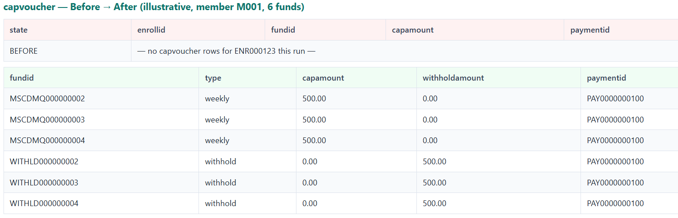

- Delete the processed queue messages
After the enrollee loop, the capmessagequeue rows that were turned into vouchers are deleted
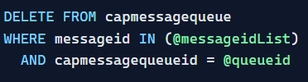

- Persist recon adjustments
If any recon adjustment was staged in Set 3, m_capadjustments.store() writes them back as PROCESSED.
The pending adjustments loaded in Set 3 were applied to the math in Set 4; now they must be closed out so they are never applied again on a future run. This is the "mark the to-do done and link it to the money" step.

Flipping PENDING → PROCESSED, stamping processdate, and linking the paymentid creates a closed, auditable loop:
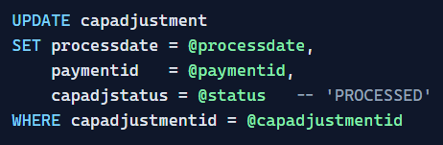

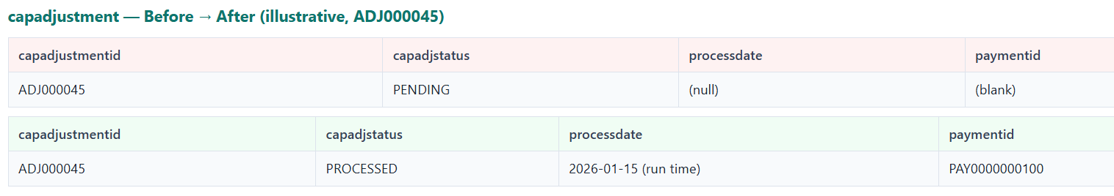

- FinalizePayment() — only on the last batch

A provider's final payment can only be correct once every member across all batches has produced its vouchers. So finalize is gated to the batch that contains the last message, and even then it waits for the queue to fully drain — because other batches may still be running in parallel. Finalizing early would cut a check missing some members.
7 a. Is the batch finished?
Because batches run concurrently, the finalizer cannot assume the others are done. It polls the queue: zero remaining rows = FINISHED, otherwise RUNNING → sleep 60s and retry (up to 600 times). This is a barrier that synchronizes many parallel batches before money is cut.

7 b · Build the payment & split per fund
A single provider payment that mixed weekly and withhold money could not be released on different schedules or reported separately. So if the vouchers span more than one fund, the finalizer mints a fresh paymentid per extra fund and re-points that fund's vouchers to it — giving one clean payable per fund.

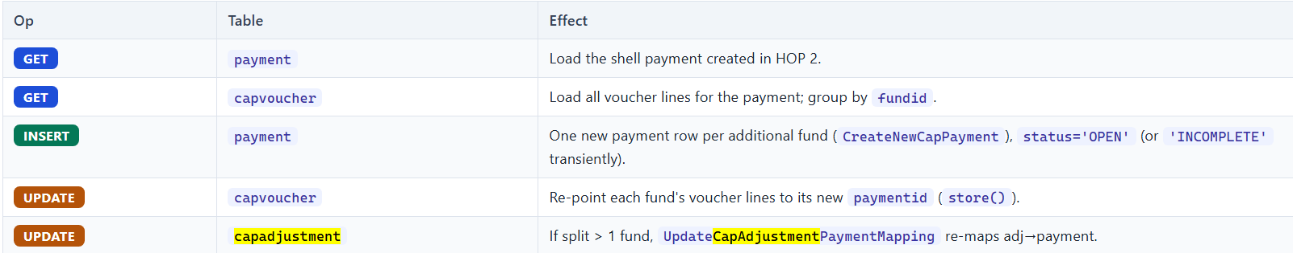

7 c · Write the fund checks
The paycheck row is the human/finance-facing summary of a payment: the single place that says "this fund, this payment, this much paid, this much withheld, this pool total." It is written per fund so each fund's check detail is independently reportable.
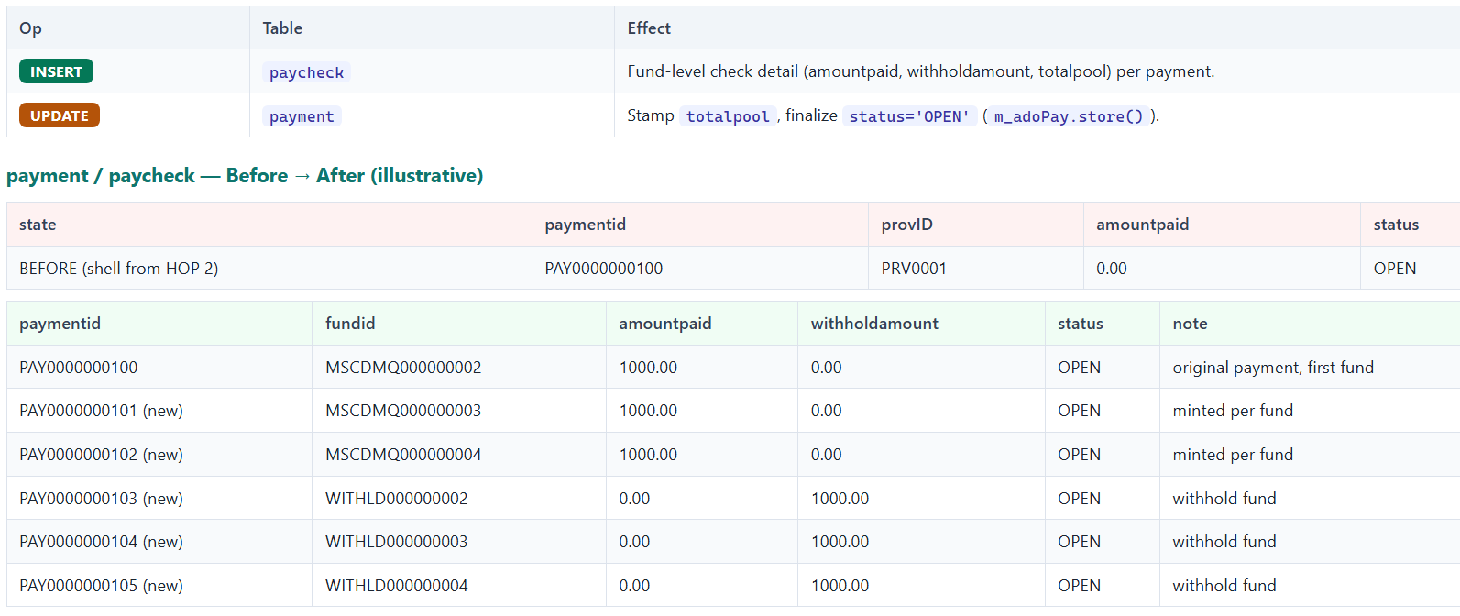

- Process-log completion
In the Finally block, the detail's failure count is read from the planintegration DB; the process-log detail is then marked COMPLETED or ERROR.

A financial batch must leave an auditable outcome. The Finally block guarantees the run is always stamped — success or failure — so operations can see whether the batch completed and, if not, how many members failed and need attention.
